- Data gathering procedure with details about sample sizes and treatments
- In 2005 a random sample of 2,584 Americans who were selected for the National Longitudinal Survey of youth in 1979 and who had a paying job in 2005 were asked to what was there annual salary as well as which of the following 4 groups their education best represented.

            - Did Not Complete High School (<12)
        - Some College (13-15)
Completed Undergraduate (16)
Advanced College Degree (>16)

- Hypothesis
Null Hypothesis (H₀) = That the mean incomes of all the Education levels are the same
Alternative Hypothesis (H_{a}) = The one of the education level means are different from the others.

- Descriptive statistics for each group
- Data set break down for Education Type
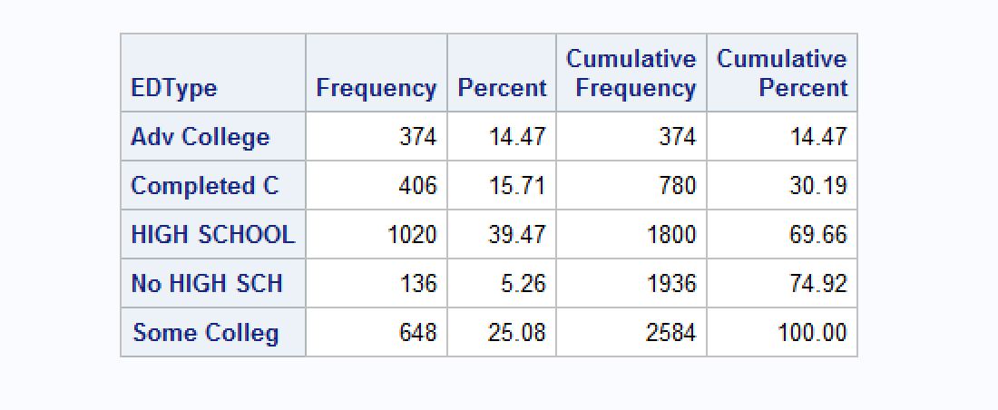

- Count, Standard Dev, Mean and 5 number summary
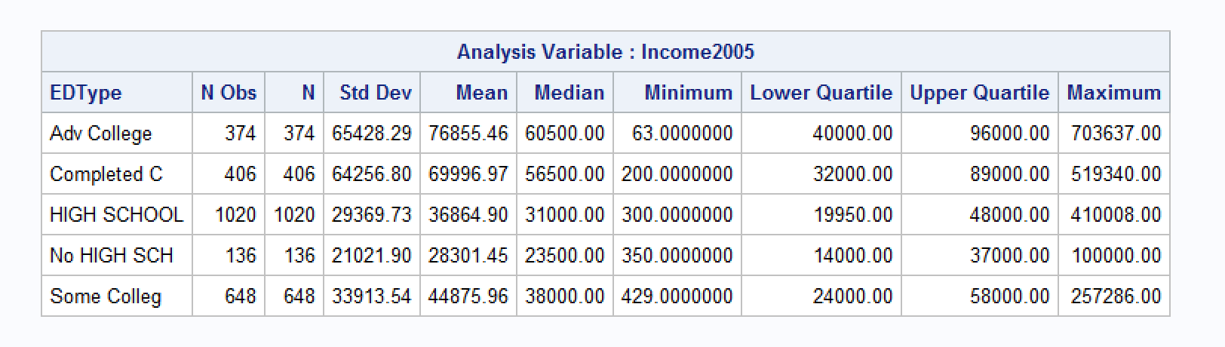

- Statistic Values
F-Statistic = 89.61
df = 4
p-value = .0001

- Residual diagnostics
- Box Plots
    - 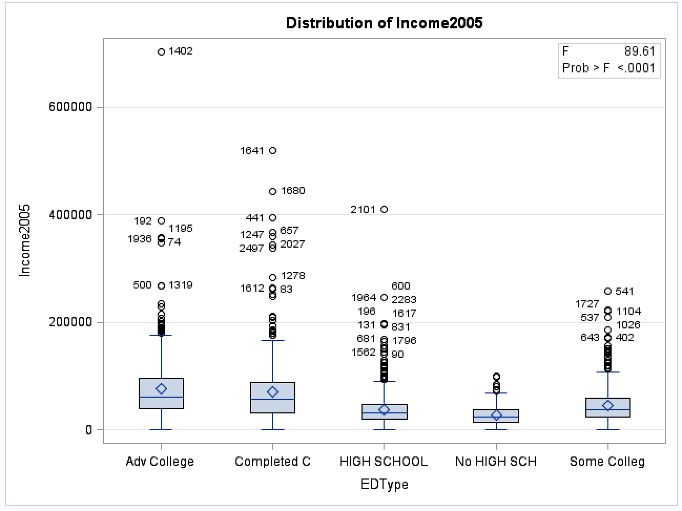

- QQPlot
    - 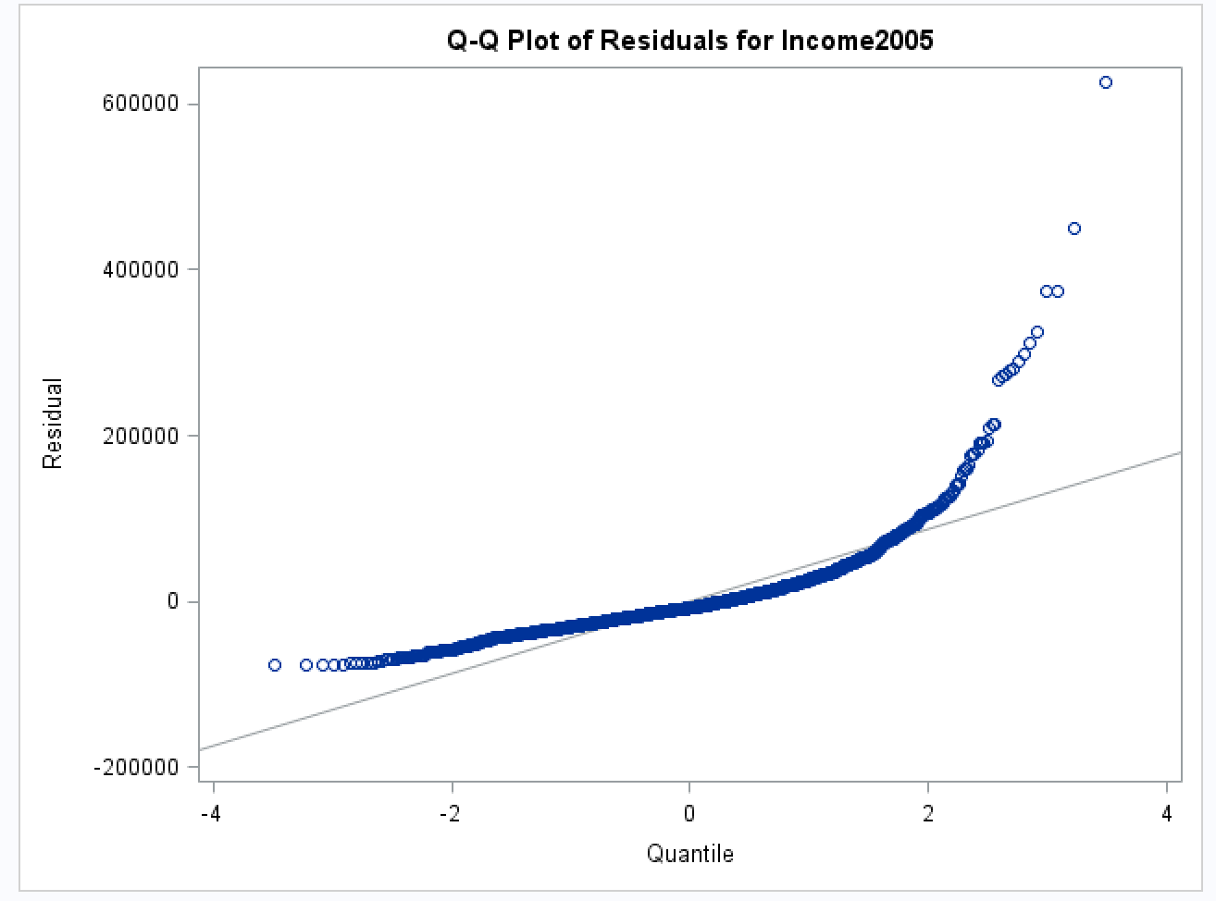
- Histogram
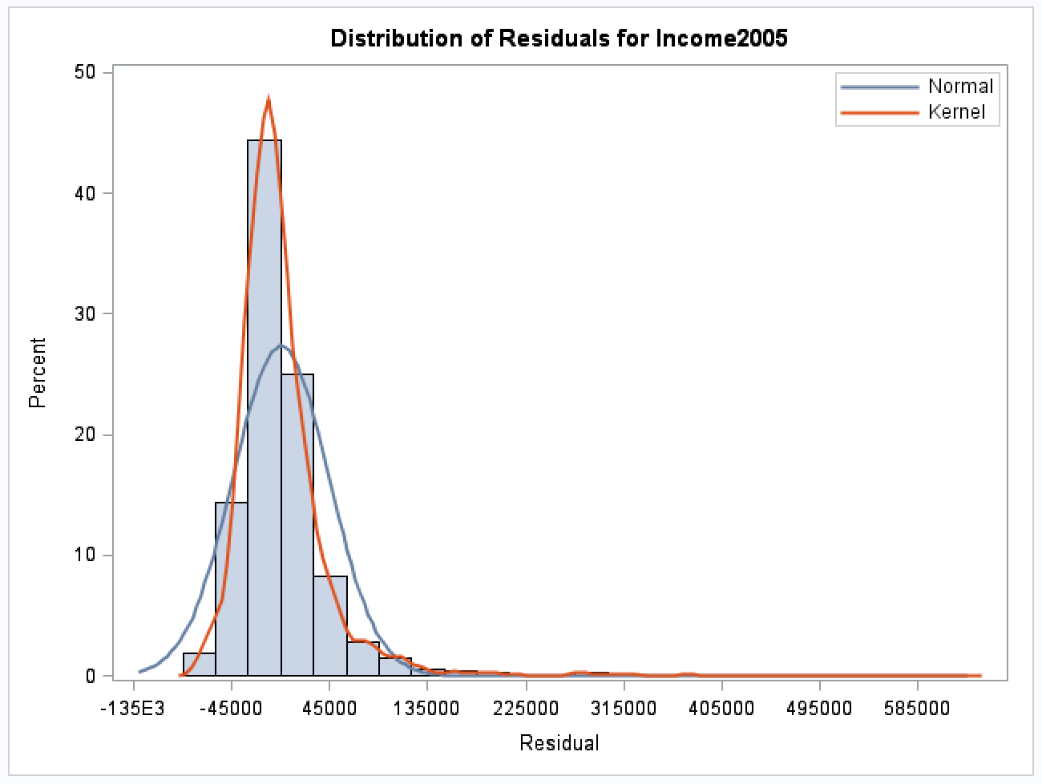

- Conclusion of the test – With a p-value of .0001, there is sufficient evidence to reject the null hypothesis in favor of the alternative that the means of incomes amongst Educational groups are not the same.

- In context of the problem – There is sufficient evidence to show that at least one of the five population is different from the others.

Code –

PROC IMPORT DATAFILE = "\\Client\C$\Users\Cmirwin\Desktop\SMU Data Sets\ex0525.csv"
OUT=surveyOrig
DBMS=csv
REPLACE;
GETNAMES=YES;
RUN;

DATA SURVEYNEW;
set surveyOrig;
IF EDUC EQ '12'
THEN EDType = 'HIGH SCHOOL';
IF EDUC EQ '16'
THEN EDType = 'Completed College';
IF EDUC EQ '<12'
THEN EDType = 'No HIGH SCHOOL';
IF EDUC EQ '>16'
THEN EDType = 'Adv College';
IF EDUC EQ '13-15'
THEN EDType = 'Some College';

run;

PROC FREQ DATA = SURVEYNEW;
TABLE EDTYPE;
RUN;

PROC MEANS DATA = SURVEYNEW N STDDEV MEAN MEDIAN MIN Q1 Q3 MAX;
CLASS EDTYPE;
VAR INCOME2005;
RUN;

PROC GLM DATA = SURVEYNEW PLOTS(UNPACK)=(DIAGNOSTICS RESIDUALS);
CLASS EDTYPE;
MODEL Income2005 = EDTYPE;
RUN;
QUIT;

